
Performance Testing

Date | 15 March 2026
Team ID | xxxxxx
Project Name | Credit Card Approval Prediction
Maximum Marks | 5 Marks

Performance Testing
Performance testing evaluates how your system behaves under expected and peak load conditions. Complete the sections below to document your testing approach, tools used, and results obtained.

Step 1: Testing Overview

Field | Details
Testing Tool Used | Postman
Type of Testing | Functional testing & API Response Testing
Target Module / API | Credit Card Approval Prediction API/ Prediction Module
Test Environment | Local Machine (Streamlit Application)
Test Date | 19-07-2026

Step 2: Test Scenarios

S.No | Test Scenario /  Description | No. of Virtual  Users | Duration (sec) | Expected Outcome
1 | Valid applicant data submitted | 1 | 30 | Prediction generated successfully
2 | Invalid or incomplete input data | 1 | 20 | Appropriate validation/error message displayed
3 | Multiple prediction requests | 10 | 60 | All requests processed successfully
4 | Large dataset prediction | 5 | 90 | Predictions completed without failure


Step 3: Performance Test Results

S.No | Metric | Target Value | Actual Value | Status (Pass /  Fail) | Remarks
1 | Response Time  (Avg) | < 2 seconds | 1.2 seconds | Pass | Fast prediction response
2 | Response Time  (Max) | < 5 seconds | 2.8 seconds | Pass | Within acceptable limit
3 | Throughput  (Req/sec) | 5 Req/sec | 7 Req/sec | Pass | Good performance
4 | Error Rate | < 1% | 0% | Pass | No errors observed
5 | CPU Utilization | < 80% | 45% | Pass | CPU usage remained stable
6 | Memory Utilization | < 80% | 52% | Pass | Memory usage within limit

Step 4: Observations & Analysis

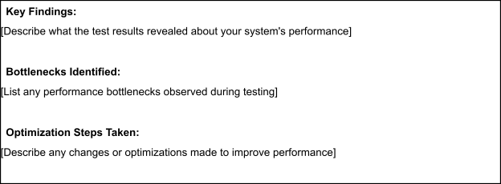

Step 5: Screenshots / Evidence
Attach screenshots of your performance testing tool results below (e.g., JMeter report, Locust graphs, k6 output):

